

Hydraulic Reset

Understanding and Operation

Northside Welding, Inc.

October 2010

Specializing in Custom Built Equipment

Manufactured in the Northwest, for the Northwest,

where we farm both sides of the acre

and are unaware of the rock piles.

Table of Contents

The Purpose and Benefits of Hydraulic Reset 3

How it Works 4

Pressures 5

Setting up your equipment (Factory Assembled) 6

Setting up your equipment (unnassembled) 7

Contact information 8

# Purpose and Benefits of Hydraulic Reset

In general, hydraulic reset equipment is used in areas where an abundance of rock or other debris is in the soil within the limits of the ground working equipment. This can be either shallow work, as in water diking or strip tillage, where the shank generally penetrates 8-10”, or deeper work, such as ripping, to depths of 20”. The hydraulic system, comprised of cylinders, hoses, fittings and an accumulator, allows the ground penetrating shank to break away when it encounters a foreign object in the soil. A hydraulic reset generally has a far greater trip range than similar spring resets to allow for more clearance of larger objects. Hydraulic pressure, unlike spring pressure, is constant and will not weaken each time it trips. Adjustments in pressure are easily achieved with the hydraulic system of the tractor.

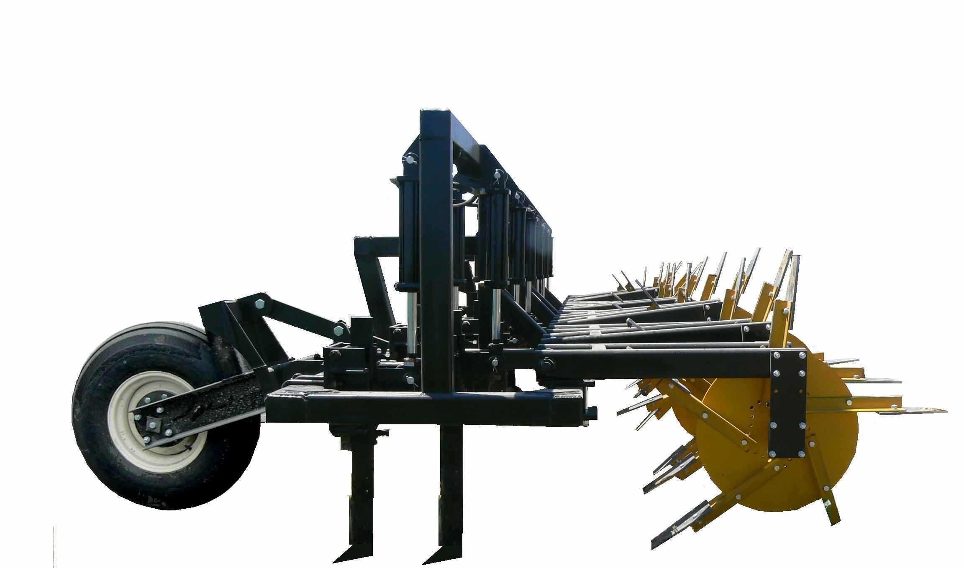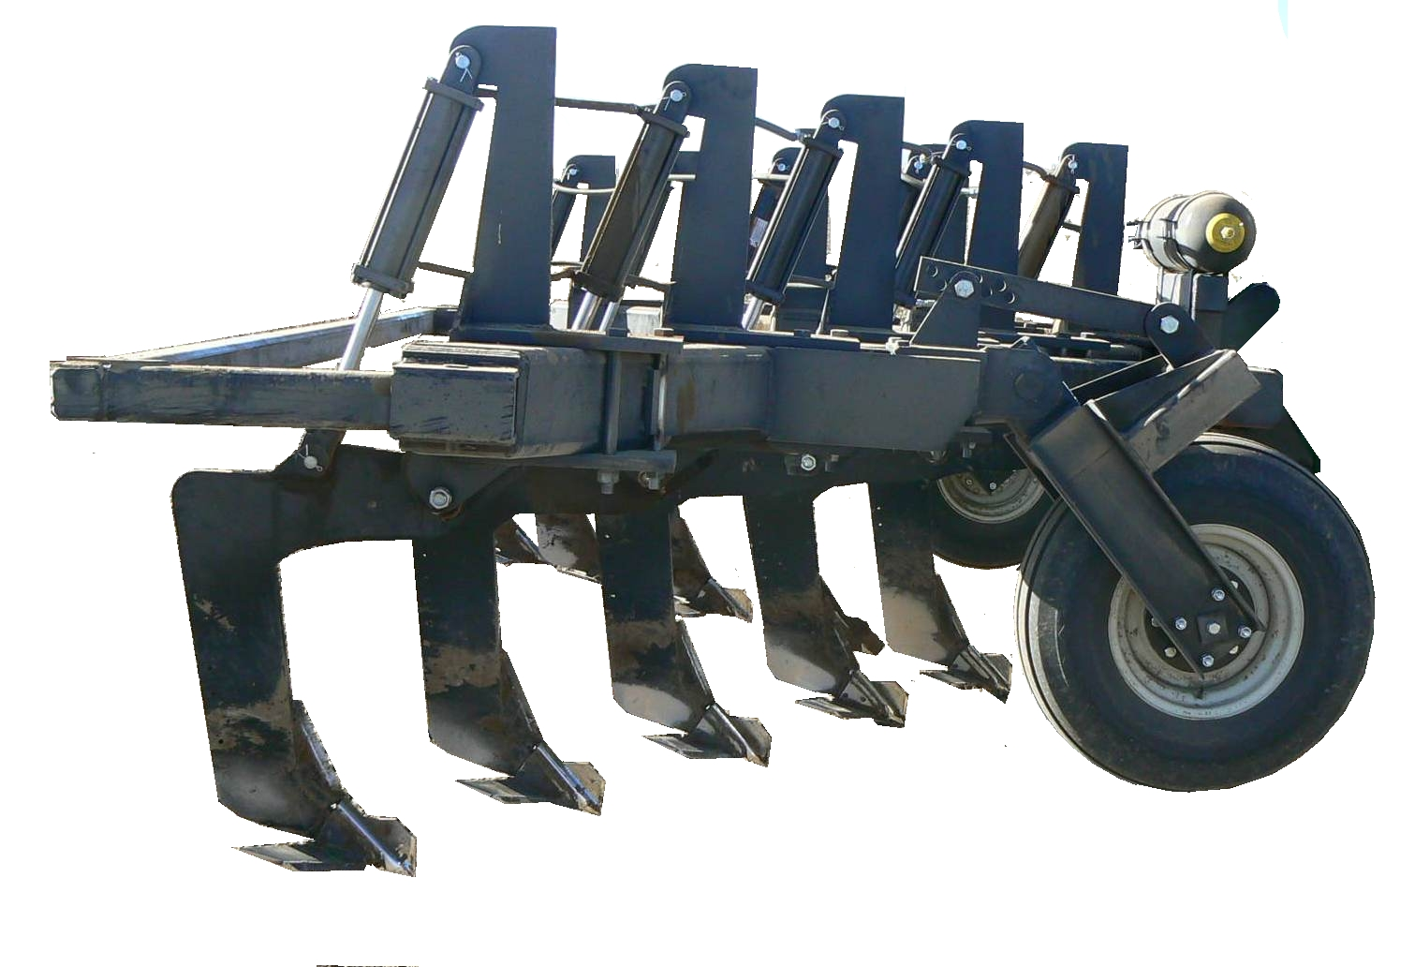

9 Shank Hydraulic Reset Ripper

1 ¼” parabolic shank

Hydraulic Reset Sugar Beet Diker

1” x 3” straight shank, 22” rows w/offset

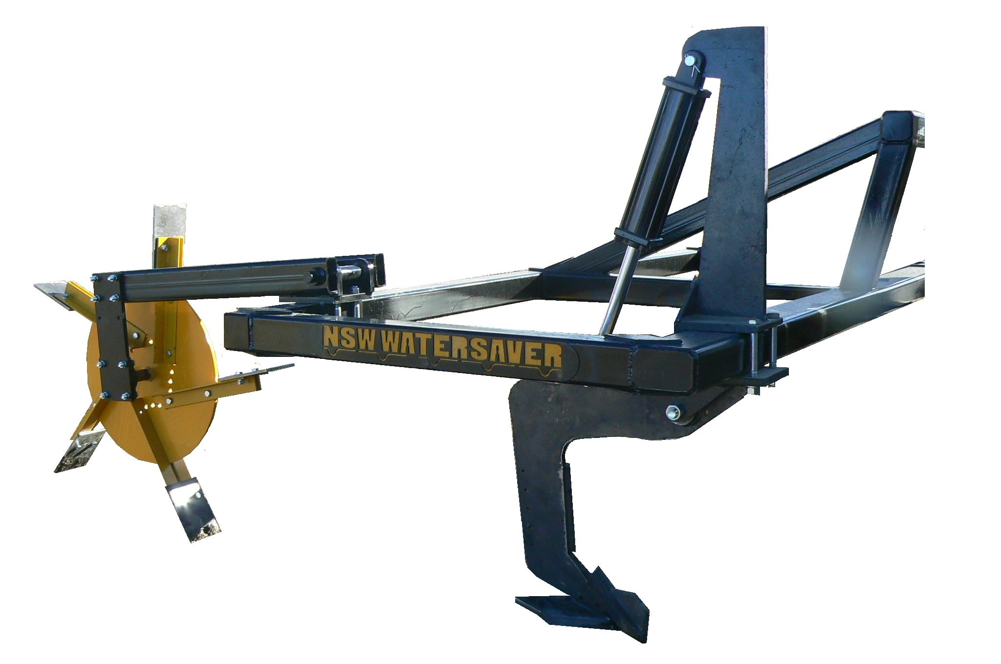

Hydraulic Reset Potato Diker

1” parabolic shank w/winged point

Winged point

The hydraulic systems designed on NSW equipment utilize standard hydraulic cylinders and fittings, easily obtained at a hydraulic retailer.

# How it works. . . . .

Though it may seem simple, there are a few things you need to know about how the hydraulic system works. Understanding the ins and outs will help you prolong the life of the system, and possibly help you avoid damage to both the hydraulic system and the implement.

The heart of the hydraulic system is the Accumulator. The name is the very description of its function-it accumulates. The accumulator is a pressurized reservoir for the hydraulic oil that is forced from the cylinder when the shank trips. The oil flows freely through the hydraulic lines back into the reservoir. It all has to do with pressure.



Inside the accumulator is a flexible bladder. The back side of the bladder is charged with Nitrogen. Nitrogen is used because of its compression characteristics, and also because the volume of Nitrogen gas is unaffected by the temperature, so the pressure will not fluctuate in changing conditions. The hydraulic oil pressure presses against the front side of the bladder. For the system to function properly, the resting pressure of the oil should **NEVER** exceed the resting pressure of the nitrogen. As shown in fig 1 below, the N2 pressure is 750 psi, the oil pressure is 650 psi.

fig 1

When the shank encounters a solid object in the ground, force is exerted on the shank, which transfers the force to the hydraulic cylinder. As the cylinder tries to retract, the oil in the system increases in pressure. When the oil pressure surpasses the nitrogen pressure, the nitrogen in the accumulator compresses to equal the pressure of the oil, as demonstrated in figure 2.



fig 2

When the shank passes the object, pressure is no longer exerted on the shank, thereby relieving the added pressure on the hydraulics. As the pressure drops below that of the nitrogen, the accumulated oil is then forced back into the system, and the shank resets.

**IT IS VERY IMPORTANT TO NEVER RUN WITH RESTING OIL PRESSURE HIGHER THAN PRESET NITROGEN PRESSURE.**

It is recommended that you run a minimum of 50 psi more nitrogen than oil. Overpowering the accumulator with oil pressure minimizes the amount of oil that the accumulator will hold. The accumulator is sized for the implement under proper pressures.

Your accumulator will come pre-charged with nitrogen. If you do not know the pre-charged pressure, contact the manufacturer prior to operating your equipment. **Improper pressure settings will cause damage to your accumulator and/or your implement which will not be covered by warranty.**

# Pressures

Many variables come to play in determining the pressure needed to run your equipment. Soil condition, moisture, depth, points, and speed are all part of the equation. You will have to experiment with pressure to determine what is best for your circumstances. Remember, the lower the pressure you can work with, the less stress it will put on your equipment. Shanks do not need to be rock solid in the clamp in order for them to function. Rule of thumb is to use only enough pressure to keep the shank in the ground.

Occasionally, some circumstances have shown that it is more difficult to keep the shank in the ground directly behind the tractor tires due to compaction. If this should occur, it is recommended that you increase the diameter of the cylinder on those shanks by ½”. For example, on a beet water saver, use 3 ½” x 12 cylinders on rows behind drivers and duals rather than 3” x 12. This gives more force with the same pressure and doesn’t increase pressure on remaining cylinders.

# Setting up your Equipment

Not all hydraulic equipment comes “Field Ready”. Although the accumulator is pre-charged with nitrogen, the hydraulic system also needs to be charged with oil prior to use. The hoses and cylinders need to be “bled” to remove any air from the system.

If you purchased your equipment assembled, the following steps will help bleed the system.

1. Loosen the “end of the line” fittings (the last cylinder on each side.
2. With the equipment hooked up to the tractor, lower the implement while pulling forward. This should trip all the cylinders. Make sure that the cylinder rod is completely retracted into the cylinder body.
3. Attach the charging hose to a port on the tractor, and open the ball valve at the accumulator.
4. SLOWLY introduce oil into the system. When oil comes out of the loosened fittings, the lines should be bled. Tighten the fittings and continue to SLOWLY add oil. The cylinder rods will gradually extend, lifting the implement.
5. When all cylinders are completely extended, SLOWLY bring the oil pressure up to the desired setting. NEVER pressurize the oil past the Nitrogen pressure.
6. Your system should be fully charged and ready for use.

If you chose to assemble the implement, the following is recommended to bleed your system.

1. When installing the hydraulic cylinders, do not attach them to the shank. Install the top pin of the cylinder only, and leave the cylinders retracted. After connecting all the hoses, leave the “end of line” fittings loose.
2. SLOWLY introduce oil into the system. When oil comes out of the loosened fittings, the lines should be bled. Tighten the fittings.
3. With the fittings tight, manually trip each shank and attach the bottom pin of the cylinder. Some of them may start to extend, but as long as the fittings are tight, no air will enter the system.
4. With all shanks/cylinders attached, SLOWLY continue to add oil to the system. All cylinders should extend and shanks reset.
5. When all cylinders are completely extended, SLOWLY bring the oil pressure up to the desired setting. NEVER pressurize the oil past the Nitrogen pressure.
6. Your system should be fully charged and ready for use.

NOTE: Damages to the implement or hydraulic components due to improper pressure or failure to bleed the hydraulic system will not be covered by warranty.

If your implement requires more oil pressure than the pre-charged nitrogen pressure due to individual conditions, more nitrogen may be added to the accumulator. Contact the manufacturer or a hydraulic retailer. Remember, the lowest pressure possible will prolong the life of the implement and components.

Northside Welding, Inc

PO Box 190

532 West, 100 South

Paul, ID 83347

Phone 208.438.5222

Fax 208.438.2359

www.northsideweldinginc.com